 | Government of India National Health Authority (NHA) |  | 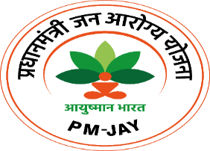
Notice Inviting Bids for empanelment of agencies for putting up Wall Painting / Digital Wall Painting for National Health Authority
RFE No: S.12014/130/2023-NHA Dated 28.03.2023
National Health Authority (NHA) was constituted, through a cabinet decision, as an attached office to Ministry of Health & Family Welfare. NHA provides overall vision and stewardship for the design, roll-out, implementation and management of Ayushman Bharat Pradhan Mantri Jan Arogya Yojana (AB PM-JAY) and Ayushman Bharat Digital Mission (ABDM). The objective of this RFE is to empanel agencies for putting up wall painting / digital wall painting. The detailed scope of work has been included in the RFE which can be obtained by authorized representative of the bidder from the O/o Deputy Director (Administration), National Health Authority, 3rd floor, Jeevan Bharati Building- Tower-1, Connaught Place, New Delhi-110001 by submitting signed non-disclosure agreement (NDA) and Letter of authorization. The RFE will be available on all working days during office hours till the last date of submission of bids.

Important Dates
Availability of RFE documents |  | 28.03.2023, 1700 hours onwards
Date and time of pre-bid meeting with NHA |  | 13.04.2023, 1100 hours onwards
Last date and time for submission of pre bid queries |  | On or before 12.04.2023, 1700 hours
Last date and time for submission of bids |  | On or before 25.04.2023, 1700 hours onwards
Date and time for opening of bids |  | 26.04.2023, 1700 hours onwards
Contact Details: iec.cons4@nha.gov.in

